2022 Wausau Area USBC
Youth City Tournament
Saturday January 8, 2022
Weston Lanes, Wausau, WI
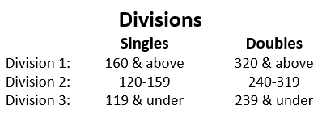

Entry Fee: Only $5.00* per Bowler!

Date/Times: 11:00am or 2:00pm

- Check in 30 -60 minutes prior to shift start time
- Practice begins 10 minutes prior to shift start time

*Tournament entry fee, prizes and scholarships are supplemented and sponsored by the Pagel/Nest Memorial and the Wausau Area USBC

Tournament Rules
- This will be a singles and doubles handicap tournament, open to Wausau area youth bowlers from Coral Lanes, Day’s Bowl-a-Dome, Weston Lanes, Marathon City Sports Center, Resch Lanes, and Paper City Lanes.
- Bowlers will bowl a total of 3 games for the entire tournament. Singles & doubles will use the same scores.
- Entrants will use their current league average (minimum 9 games) or their previous season’s average, whichever is higher as of Jan. 1, 2021.
- Handicap will be 100% of 210 for all divisions.
- Winners of singles & doubles will be determined by total pin fall plus handicap. Scholarships will be awarded on approximately a 1:4 ratio.
- Tournament director has final decision regarding any discrepancies.

See your youth director to sign up! Registration deadline is January 2, 2021.
Make checks payable to “Wausau Area USBC”
Send all Entries and Fees to
Niki Rosenow
5705 Gordon St.
Weston, WI 54476

Please circle your preferred shift: 11:00am 2:00pm
 | Bowler #1 | Bowler #2
Name
Address
Phone Number
Last Year’s
Book Average
Center (circle one) | Coral Weston Resch Days  Paper City Marathon City | Coral Weston Resch Days  Paper City Marathon City
Sweatshirt Size* | Youth: S M L XL  Adult: S M L XL 2X 3X | Youth: S M L XL  Adult: S M L XL 2X 3X
*Sweatshirts are awarded to winners in each division

